Author: Santiago Bermudez

1. **List 3 different protocols that appear in the protocol column in the unfiltered packet-listing window in step 7 above.**

Three types of protocols that appear in the protocol column in the unfiltered packer-listing window are:

* UDP
* QUIC
* SNMP

*I got these answers by looking at the protocol column to the right below!

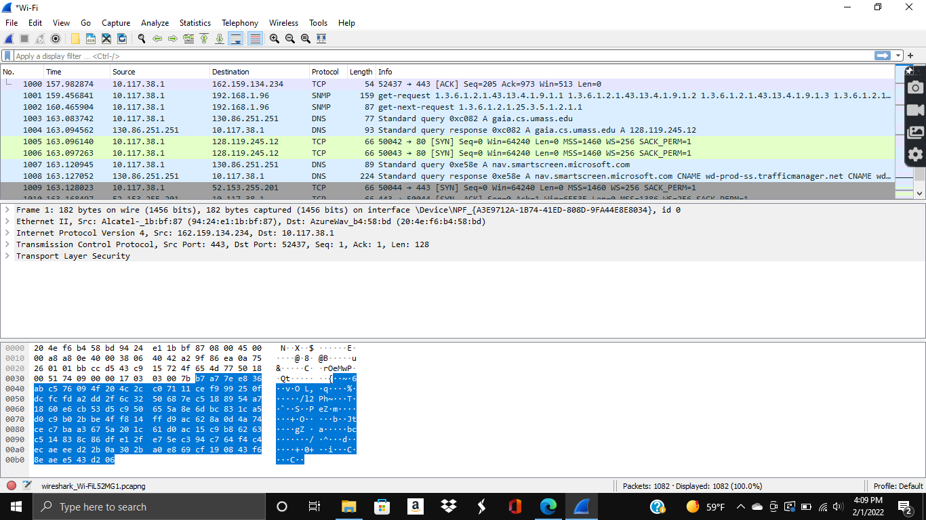

1. **How long did it take from when the HTTP GET message was sent until the HTTP OK reply was received? (By default, the value of the Time column in the packet-listing window is the amount of time, in seconds, since Wireshark tracing began. To display the Time field in time-of-day format, select the Wireshark View pull down menu, then select Time Display Format, then select Time-of-day.)**

For the link that was provided in the lab, it took from 16.279439 to 16.467756 or from 12:42:16.432448 to 12:42:16.620765 in time-of-day format. So, it took 0.188317 seconds.

*I got the screenshot in the amount of time since Wireshark tracking began below and in time-of-day format from the printed http messages. I forgot to take the screenshot for the time of day format from the packet-listing window, but this is all from the same attempt. I did the time calculations from both formats just to prove it.

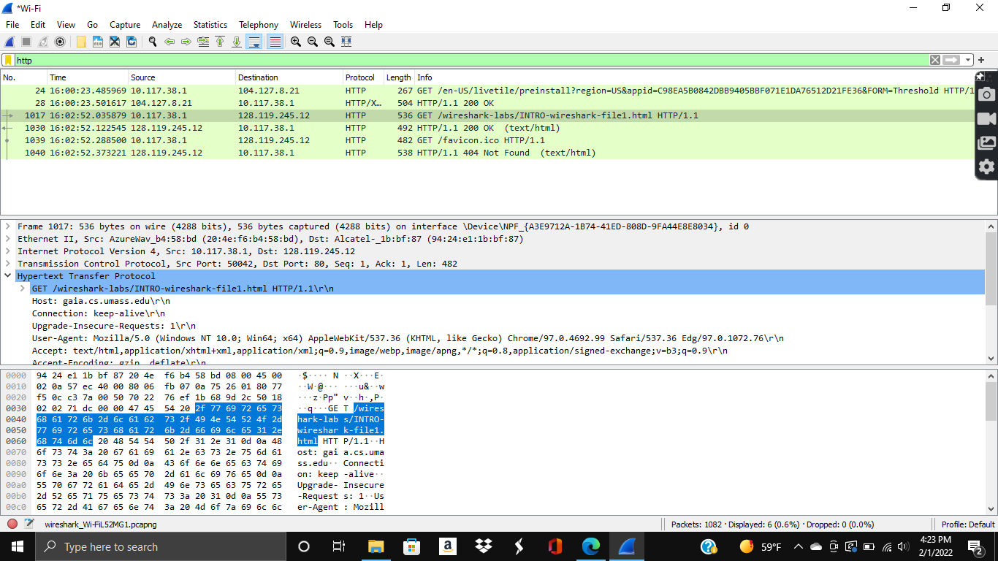

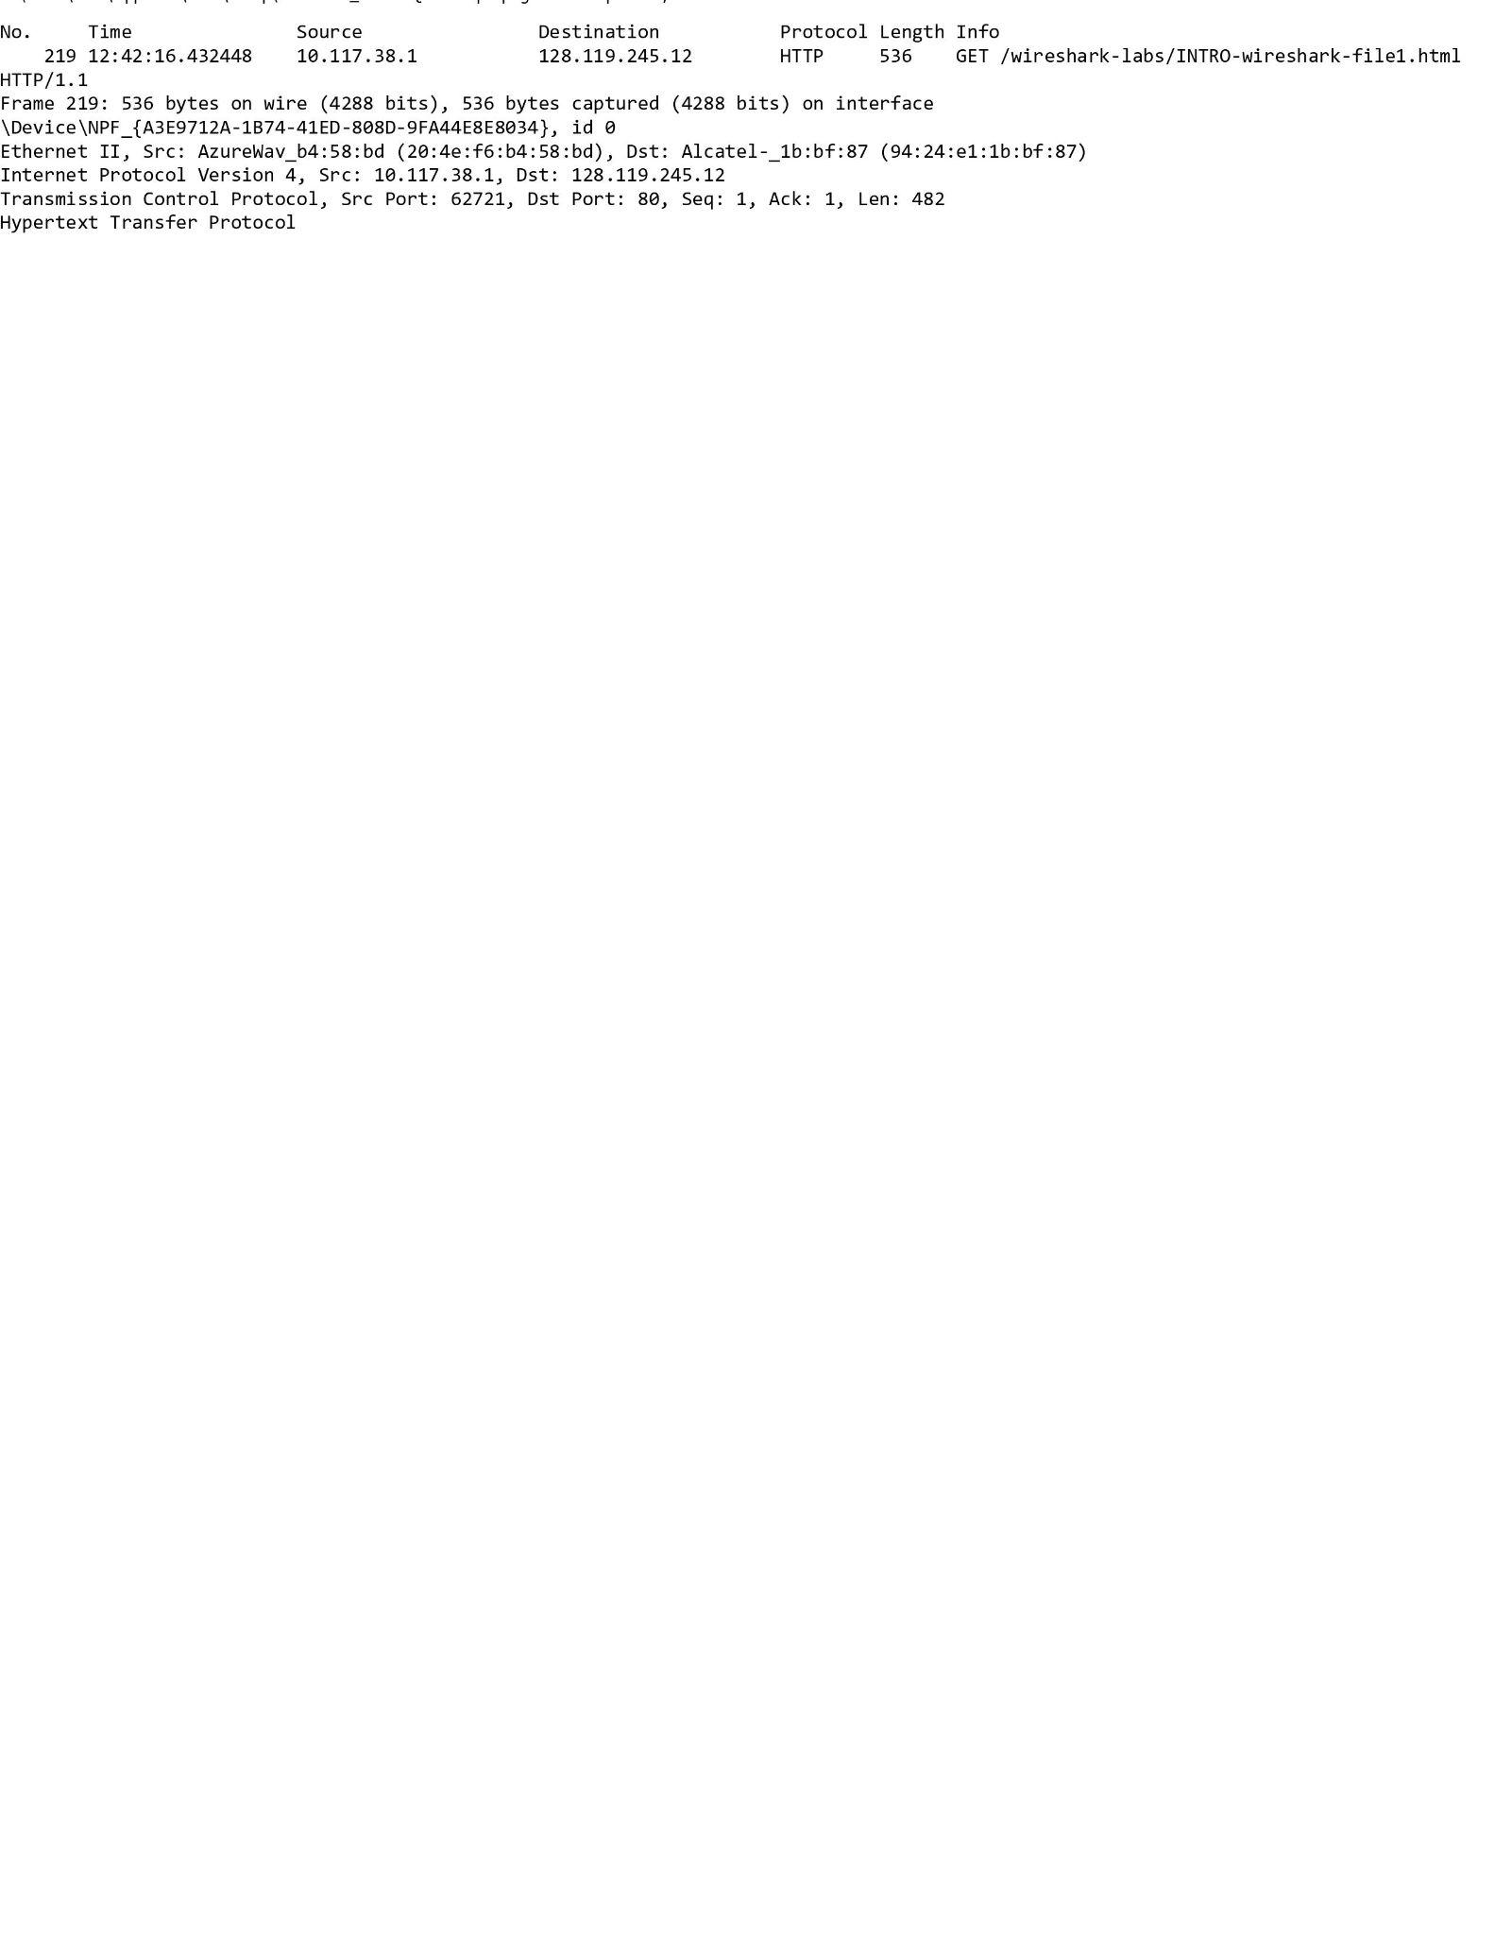

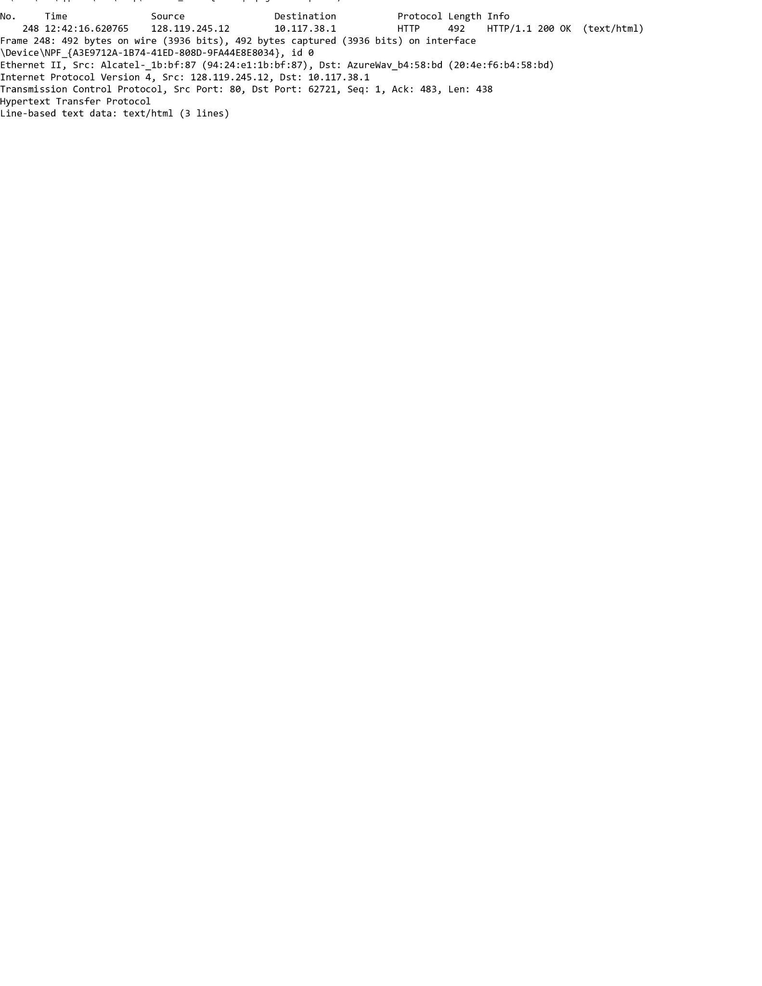

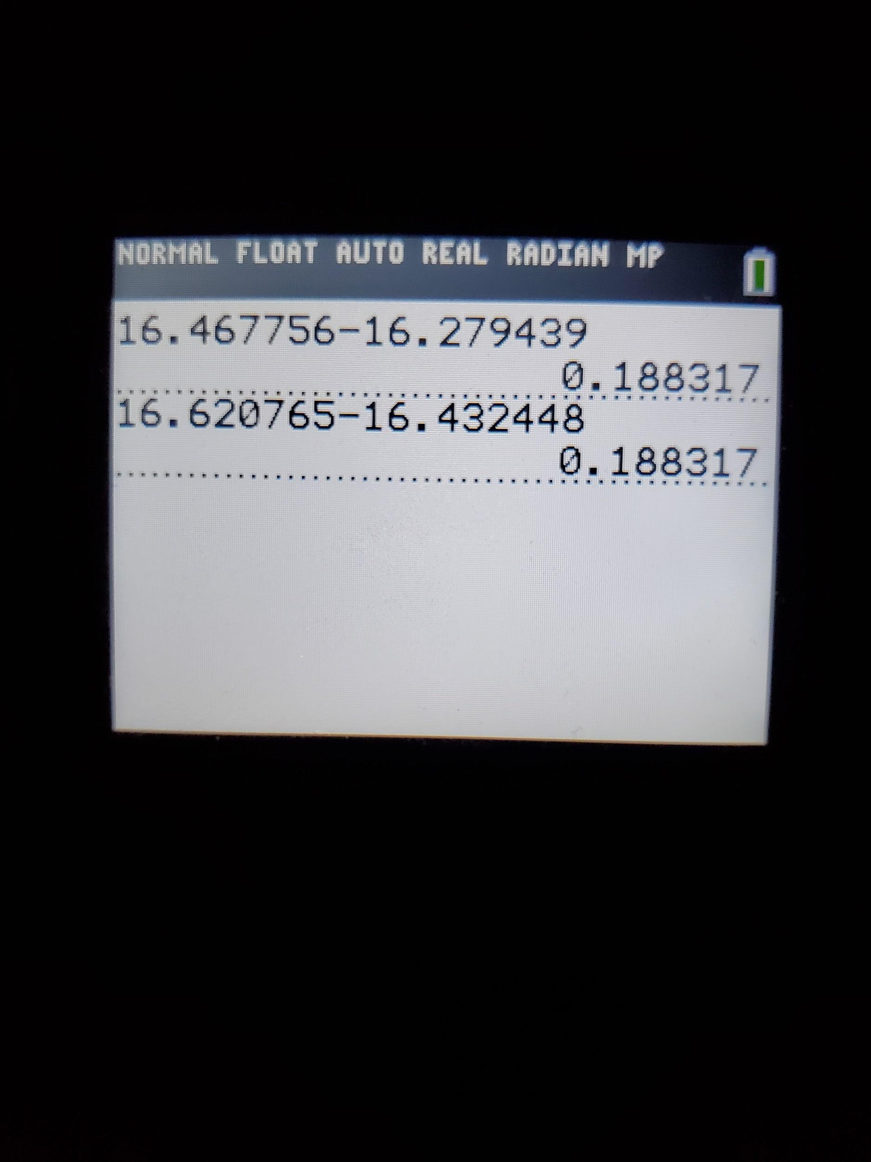

1. **What is the Internet address of the gaia.cs.umass.edu (also known as wwwnet.cs.umass.edu)? What is the Internet address of your computer?**

The internet address of gaia.cs.umass.edu is: 128.119.245.12

The internet address of my computer is: 10.117.38.1

*I was able to verify my IP address from looking at my settings as you will see below. From there, I can infer what the internet address of gaia.cs.umass.edu was.

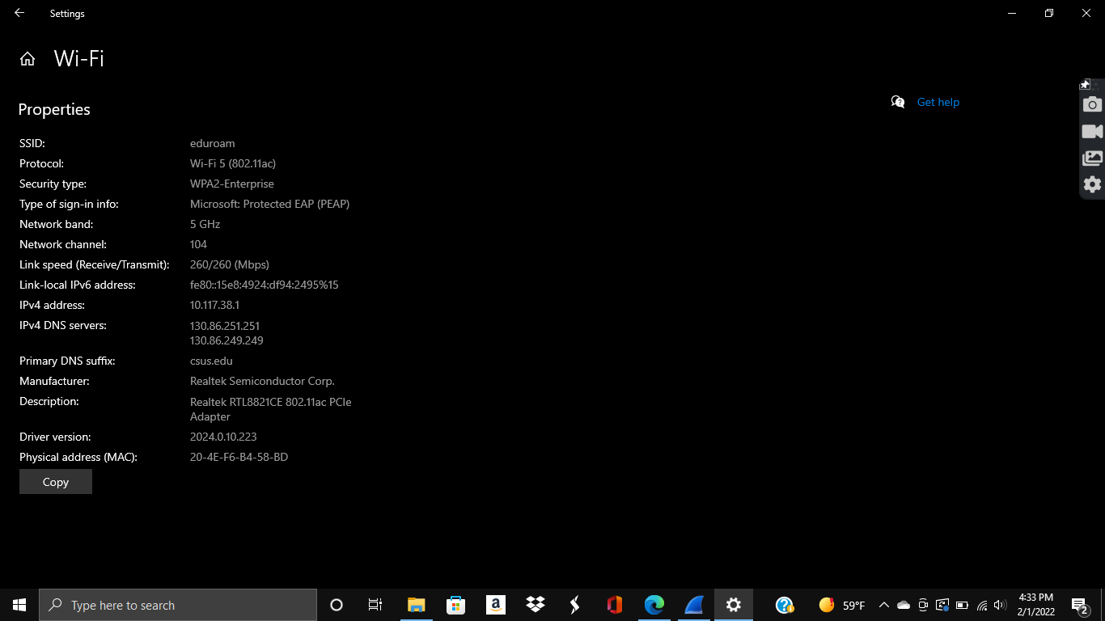

1. **Print the two HTTP messages (GET and OK) referred to in question 2 above. To do so, select Print from the Wireshark File command menu, and select the “Selected Packet Only” and “Print as displayed” radial buttons, and then click OK.**

*Printed images posted below!



**\*Below are just some screenshots I took of the outcomes I got while following the instructions in the lab!**

